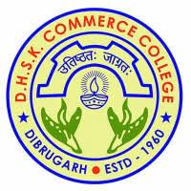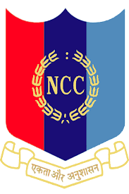
NCC ENROLMENT PROCEDURE 2023-2024
STAGE WISE ENROLMENT CRITERIA

STAGE : 1  PHYSICAL TEST | PARTICULARS | MALE | FEMALE | MARKS
STAGE : 1  PHYSICAL TEST | Minimum Height | 160 cm | 152 cm | 20
STAGE : 1  PHYSICAL TEST | Running ( 1.5 km ) | 5 minutes | 7 minutes | 20
STAGE : 1  PHYSICAL TEST | 5 meters shuttle per minute | 12 rounds per minute | 10 rounds per minute | 10
STAGE : 1  PHYSICAL TEST | Push ups per minute | 20 times per minute | 15 times per minute | 15
STAGE : 1  PHYSICAL TEST | Sit ups per minutes | 25 times per minute | 20 times per minute | 15
STAGE: 2 WRITTEN TEST | Sl.no | Types of Questions
STAGE: 2 WRITTEN TEST | 1 | Multiple Choice Questions ( MCQ) ( general awareness on ncc, defence related including army, navy, and airforce ,arithmetic, mental aptitude) |  | 50
STAGE: 2 WRITTEN TEST | 2 | Thematic Apperception Test ( TAT) |  | 10
STAGE: 2 WRITTEN TEST | 3 | Word Association Test (WAT) |  | 10
STAGE: 2 WRITTEN TEST | 4 | Situation Response Test (SRT) |  | 10
STAGE : 3  CULTURAL AND OTHER CO-CURRICULAR ACTIVITIES TEST | Each students shall perform or showcase their cultural activities like bihu, shattriya dance etc and other activities in the form of dance or songs with traditional instruments |  |  | 20
STAGE : 4  PERSONAL INTERVIEW | Each students shall face personal interview to be conducted by CO, PI STAFFS, ANO and senior cadets of the college NCC unit |  |  | 20
TOTAL MARKS |  |  |  | 200

N/B: STUDENTS PERFORMING WELL IN ALL THE 4 STAGES SHALL BE FINALLY SELECTED
STUDENTS CAN COLLECT APPLICATION FORM FROM NCC OFFICE ON OR BEFORE 10TH AUG 2023

ANO
DHSK COMMERCE COLLEGE, DIBRUGARH

